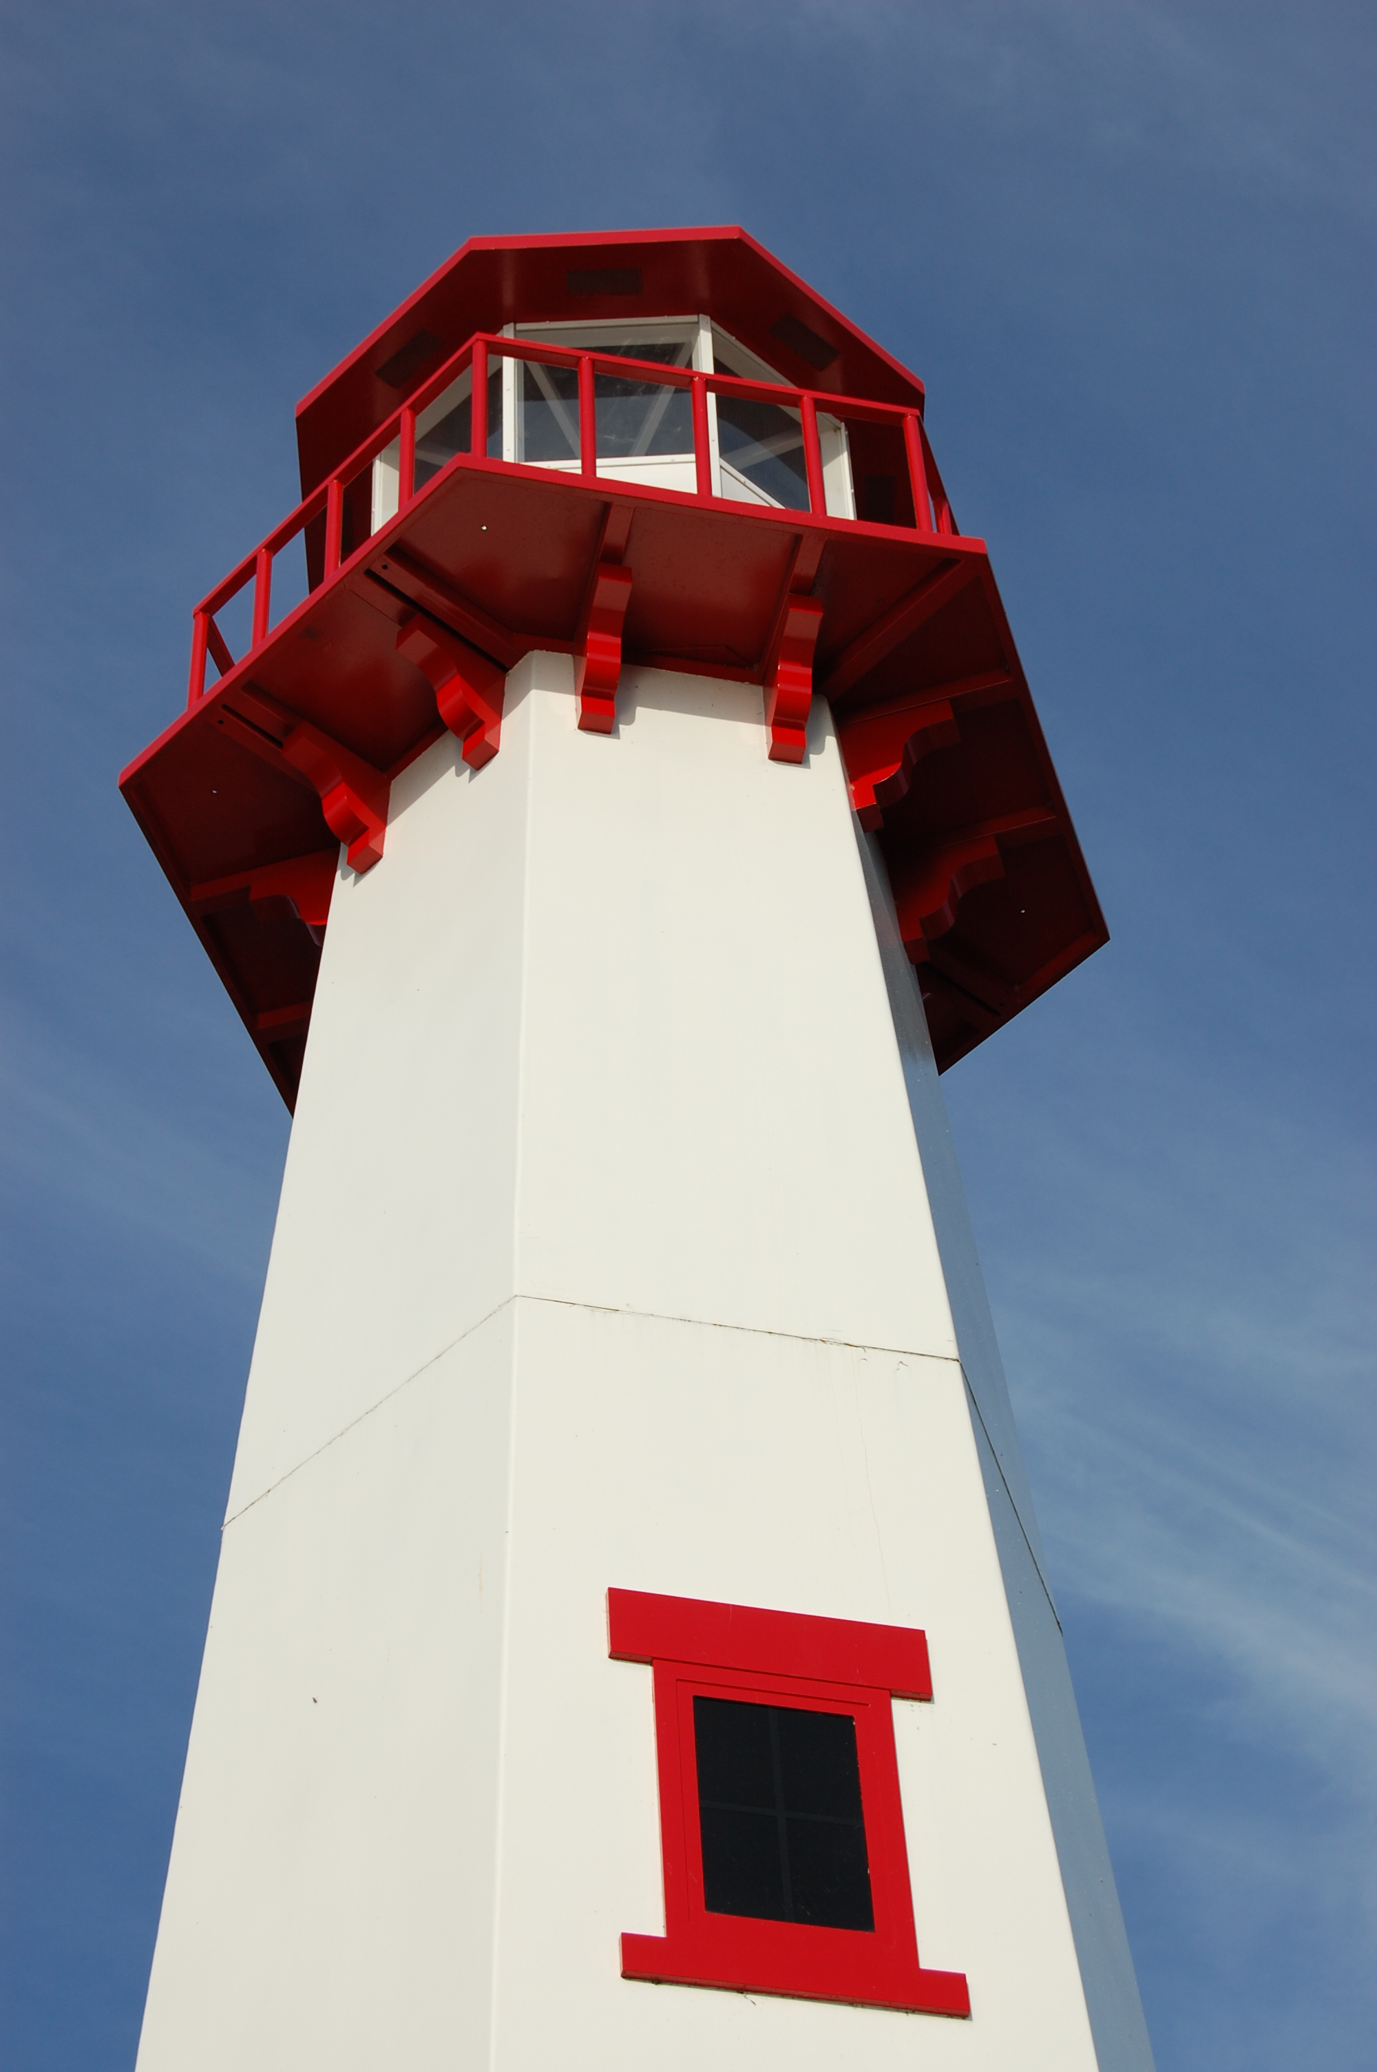
THE LIGHTHOUSE
Nonprofit Org.
U.S. Postage
PAID
St. Ignace, MI 49781
Permit No. 55

,

Newsletter for August 2016

By day you led them with a pillar of cloud, and by night with a pillar of fire to give them light on the way they were to take. Nehemiah 9:12

Message from Our Pastor

Sisters and Brothers in Christ,

I can hardly believe it’s been a year since I started. To be very honest it seems like yesterday! There have been many firsts, some that were surprising and some that just came along with the call. As I look back, I still have just a couple to go!

As I sit here typing this, watching the sun glisten off the lake, I truly feel blessed to serve two wonderful congregations. You have put up with me when I do the typical first call bumbling around, and you have supported me when times were difficult for me and my family. We are very thankful for that.

I am looking forward to the upcoming year, continuing some things we have started and looking forward to some new things. As we know, financially our churches are struggling yet we are blessed with so many gifts, and that gives me hope. A few of those gifts that we can utilize like the soup luncheons and community dinners, and many other creative ideas I have heard, that have worked through the years. With all that in mind I am looking for some people who will join me in looking at a stewardship project for the church. I have some ideas but I’m looking for someone who will work with me to make it happen. So please if you’re feeling moved by the spirit let me know, it will be exciting!

May you all have a very safe and blessed rest of the summer. Take care and God bless you all!

Yours in Christ,
Pastor David

Noisy Offering

The noisy offering for August 7th
will go to Project Backpack.

Newsletter
The August Newsletter was not adopted. ☹

Vacation Bible School

All young people from Pre-school to 5th grade are invited to join us for Vacation Bible School. Our joint VBS will be held at the United Methodist Church from August 8th to August 11th. It will be in the evenings from 6 pm to 8 pm. Please come and enjoy!


Mid-week Services

For the first two weeks in August we will have Wednesday evening services at 7 pm for those who cannot make it to the Sunday morning services. Join us to share the good news!

Pastor on Vacation

Pastor David and Family will be gone on vacation from August 12th – August 25th. He has arranged for pulpit supply on August 14th and August 21st. Anyone needing a pastor during that time may contact Pastor Matthew Lamb at 717-805-4210 or at matthewlamb77@yahoo.com.

Spartan Labels

We are still collecting Spartan Labels to raise money for Zion. Collect the UPC labels from any Spartan product and bring them to the church.

Anniversaries in August

August 3 Mike & Janet Herman
August 6 Mark & Carol Elmblad
August 6 Michael & Faith Gaubault
August 17 Bob & Debbie Brandstrom
August 17 Jon & Connie Olsen
August 23 Durance & Becky Paul
August 28 Charlie & Audrey Stenson
August 28 Les & Debbie Therrian

Birthdays in August

Aug 2 Amber Anderson
Aug 2 Molly Dandona
Aug 5 Cierra Barker
Aug 6 Joe Chalmers
Aug 6 Bailey Ryerse
Aug 7 Sandy Feleppa
Aug 8 Ethan Shepard
Aug 8 Craig Therrian
Aug 11 Adrian Coleman
Aug 11 Chelsey Coleman
Aug 11 Madison Coleman
Aug 13 Tyler Chambers
Aug 14 Stephanie Jenkins
Aug 14 Lana Lennington
Aug 14 Dottie Glashaw
Aug 16 Cole Garen
Aug 17 Shari Baron
Aug 19 Haley Dodds
Aug 21 Matthew Rogers
Aug 22 Donovan Insley
Aug 23 Lisa Rogers
Aug 24 Nicole Garen
Aug 25 Kristine Vallier
Aug 26 Gary Sorenson
Aug 27 Les Therrian
Aug 28 Duane Gamble
Aug 29 Gunnar Olsen
Aug 30 Michael Gaubault
Aug 30 Jim Ryerse
Aug 31 Savannah Barker

Baptismal Anniversaries

August 1 Linda Wilkins

August 1 Dianne Nelson
August 10 Aubree Vallier
August 12 Debbie Therrian
August 18 Bob Brandstrom
August 18 Wendy McCluskey
August 20 Abby LaLonde
August 28 Nevaeh Wells

Prayer List

(If you would like someone added to the prayer list, please call or email the church)

Carl & Mary Belonga, Dave & Lois Movalson, LaTaunya Paquin, Barb Lehto, Charlie Lamoreaux, Ed Idalski, Luanne Keinonen, Joel Morabito, Judy Schlehuber Bridges, Mary Sklenar, Jackie Rippit, David & Connie Ogg, Tom & Taffy Coffey, Helen Nakarado, Ed Heenan, Eric Rose, Charles Beeck, Phillip Brooks, Joe & Sharon Chalmers, Joanne Tamlyn, Bethany Wiese, Nadine Dandona, Glady Tamlyn, Patty Thibault, Dan Levay, Bruce McVannell, Jim Rose, Randy Kaminsky, Gayle Kaminsky Pande, Caroline Akers Holt, Christine Jamieson and the friends and family of Paul Ogg.

Trinity Worship Families

Aug 7 Chalmers Family
Aug 14 Rose Family
Aug 21 Kennedy Family
Aug 28 Movalson Family
Servants for Zion

Ushers & Greeters

Aug 7 Judy Ryerse & Marialana Nygard
Aug 14 Sandy & Fred Feleppa
Aug 21 Mike Lehto & Mike Herman
Aug 28 Les & Debbie Therrian

Lectors

Aug 7 Paul Shepard
Aug 14 Judy Ryerse
Aug 21 Lorraine Graham
Aug 28 Richard Galor

Communion Assistants

Aug 7 Steve Christiansen
Aug 14 Jerry Fenlon
Aug 21 Mary Christiansen

Altar: Judy Ryerse
Money Counters: Carol Elmblad and Susan Fenlon

August 21st we will be doing the service at Long-Term Care. Please help out if you can.

The Usher duties are:
- Arrive 30 minutes before church
- Pass out bulletins and welcome guests
- Help with the offering and communion
- Record attendance

Zion Funeral Committee Aug - Nov

Team Leader: Linda Wilkins (430-1465)
Co-leader: Rita LaVake (906) 298-0005

Council Meetings

Zion’s Council Members

President: Lana Lennington 643-6576
Vice-President Paul Shepard 984-2069
Co-Treasurers: Dawn Akers 643-7552
Co-Treasurers: Lana Lennington 643-6576
Secretary: Steve Christiansen 298-1051
Mary Christiansen 235-6123
Jerry Fenlon 643-8730
Tim Idalski 643-6574
Karen Schlehuber 643-0311

Trinity’s Council Members

President: Jerri Rose 292-5570
Vice-President Tracy Movalson 292-5581
Secretary: Sharon Chalmers 292-5440
Treasurer: Pega Kennedy 292-5633
Co-Treasurer: Jim Rose 292-5570
Financial Secretary: Tom Gustafson 292-5460
WELCA: Pega Kennedy 292-5633
John Kennedy 292-5633
Lois Movalson 292-5581

Treasurer's Report for Zion
January 1, 2016 through July 16, 2016
Income:
 | Amazon Smile Foundation | 15.45
 | Building | $ 155.55
 | Church Use Income | $ 200.00
 | General | $ 38,940.65
 | Thrivent Financial Income | $ 44.00
 | Trinity Share | $ 7,473.15
 | TOTAL |  | $ 46,828.80
Expenses:
 | Administration | $ 3,114.02
 | Benevolence | $ 453.60
 | Church Maintenance | $ 7,219.74
 | Education | $ 188.98
 | Parsonage Maintenance | $ 1,542.79
 | Pastoral | $ 32,082.70
 | Worship | $ 2,850.30
 | --To Building Fund | $ 100.00
 |  |  | $ 47,552.13
 |  |  | -723.33
***********************************************************
Thrivent Financial Investment Fund |  |  | $ 273.11
General fund balance: |  |  | $ (1,312.05)
Kitchen/Building Fund balance |  |  | $ 1,048.91
General fund owes building fund: |  |  | $ 55.00
General fund owes Mission Endowment fund: |  |  | $ 7,995.00

Zion Lutheran Council Meeting
July 20, 2016

Council Members Present: Jerry Fenlon, Steve and Mary Christiansen, Karen Schlehuber, Dawn Akers, Pastor Dave.

Pastor Dave called the meeting to order at 6:05.

Pastor Dave read devotions entitled "Everyday Miracles".

1. Pastor's Report:

A. Things are going well.

B. Pastor will be on vacation from August 12 through August 25. He has arranged pulpit supply for Sunday Services on August 14 and August 21. Pastor Matthew Lamb will be available if anyone should need to talk to a pastor.

C. A pipe needed to be replaced in the parsonage basement due to a leak. Parsonage is in need of a 2nd water meter for garden watering purposes. Jerry will check with City for installation.

2. Treasurer's Report:

A. Church income through offerings continues to be low and we need to increase intake somehow. A committee to study options will be formed in the fall.

Treasurer's Report was discussed and approved.

3. Secretary's Report:

A. Elevator is still not working. Need to find a different repair company. Steve will get name of company US Forest Service uses on their elevator, whom they have had good luck with.

B. Women's Group met after service on July 17. A decision was made to sell the old heavy tables for $25 each, and buy new, lighter replacement tables.

Secretary's Report was discussed and approved.

4. Old Business:

A. A date for the joint Zion/Trinity picnic was chosen (September 11 at Coast Guard Park). Pastor Dave will coordinate with Trinity.

5. New Business:

A. No Zion Council Meeting in August. Meetings will resume in September.

B. Zion will be changing phone and internet services to Charter Communications in the near future.

C. We need to back up church hard drive and test Lorraine and Pastor's computers for viruses to increase their speeds. Dawn will work with Lorraine to make this happen.

D. Zion will be reviewing the Church Constitution in the Fall. Dawn and Jerry will form a committee and make recommendations to the full council beginning in September.

The meeting closed with the Lord's Prayer at 6:50.

Notes respectfully submitted by Steve Christiansen

Trinity Council Meeting
July 19, 2016
Those present: Pastor David, Jerri Rose, Tracy Movalson, John and Pega Kennedy, Tom Gustafson.
Pastor opened the meeting with a Martin Luther's devotional reading from "Faith Alone" entitled "Everyday Miracles"
PASTOR'S REPORT. Pastor David talked about organizing a joint picnic with Zion. Pastor will be on vacation August 11-25.
SECRETARY'S REPORT. Read and Approved
TREASURER'S REPORT. Read and Approved
FINANCIAL SECRETARY'S REPORT. Tom expressed his frustration with so many different funds and keeping track as to where to put contributions and/or withdrawals. His report was read and approved.
OLD BUSINESS
1. To recap the Midsummer Pole Raising went well and $90.00 was collected in our pole raising jar.
NEW BUSINESS
1. Quarterly statements are coming out and we are catching up.
2. This is the last year for the bishop before retirement.
3. Next fall is the 500th anniversary of the reformation.
The meeting was adjourned with the Lord's Prayer at 6:45 p.m.
Respectfully Submitted,
Sharon Chalmers, Secretary

Contact Information

Pastor David Tielbar may be reached at 906-984-2051 or at david.tielbar6@gmail.com. In an emergency, you can reach the Pastor’s cell phone at (563) 880-4512

Church telephone: 906-643-7870 - Answering machine
The secretary will usually be in the office on Tuesday and Thursday mornings from 9 - 12

To email the church is: ziontrinity950@yahoo.com
The website is at http://zionstignace.com/home.html
- Find us on facebook at www.facebook.com/zionstignace

Zion Evangelical Lutheran Church and Trinity Lutheran Church are congregations of the Northern Great Lakes Synod and the Evangelical Lutheran Church in America.

Trinity’s Sunday Service is at 9 a.m.
Zion’s Sunday Service is at 11 a.m.
HOPE Chest

The HOPE Chest hours are:

Fri - Mon: Closed
Tues: 10am - 6pm *donation drop-offs 10-5
Wed: Noon - 6pm *donation drop-offs Noon-5
Thurs: 10am - 6pm *donation drop-offs 10-5
Volunteers are needed! Please consider giving of your time and talent to our mission. Our volunteers are vital to the success of the HOPE Chest. There is a wide range of volunteer positions available, during open hours and on Wednesday evenings from 6 - 8 pm to stock shelves. Please stop in to see how you can help or call Cathie Tielbar at 643-7360.

That’s a Joke, Son

A new pastor was visiting in the homes of his parishioners. At one house it seemed obvious that someone was at home, but no answer came to his repeated knocks at the door. Therefore, he took out a card and wrote "Revelation 3:20" on the back of it and stuck it in the door. Revelation 3:20 begins "Behold, I stand at the door and knock."
When the offering was processed the following Sunday, he found that his card had been returned. Added to it was this cryptic message, "Genesis 3:10."
Reaching for his Bible to check out the citation, he broke up in gales of laughter. Genesis 3:10 reads, "I heard your voice in the garden and I was afraid for I was naked."

Community Dates to Remember

August 2: Don’t forget to vote!

August 19 – 20: Motorcycles on the Mac. Join us as the St. Ignace Events Committee hosts a new version of the “Midnight Ride”, an annual event to raise money for the Juvenile Diabetes Research Foundation.

August 26 – 28: Rendezvous at the Straits. Father Marquette National Memorial, Boulevard Drive, St. Ignace. Public Welcome. Cost: Admission $5.00, Elders $4.00, Under 5 Free

Looking back

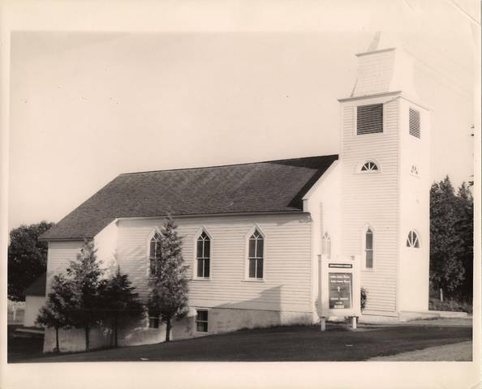
The old Lutheran Church of St. Ignace circa 1957.

